## Chapter1 Analysis

1.Analysis

1.1.Motivation

Fireisverydeadlyanditleadstolossofhumanlifeandproperty.Fire detectionsystemsarenecessarytoreducethedestructionofpersonal belongingsandcausedbyfirebothmanmadeandinduced.Oneofthe mostdestructivepropertiesoffireisthatitspreadsexponentiallyand withtherightmediumcanspreaduncontrollably.Thisiswhytimely detectionoffireisnecessaryforavoidingafirehazard.TheInternetof Thingsisacollectionofsensor,actuators,software,electronics embeddedwithhomeappliances,physicaldevicesandvehicleswhich connectwitheachothertoconnectandexchangedatewhichhelpsin increasingtheefficiencyofeverydayappliancesusingcomputer-based systems.

1.2.ProblemDefinition

Firescauseseriousdamageanddisruptsdailylifeinadevastating manner.Hencepreventingthemorreducingtheireffectsisatop priority.Thoughtherearemanysystemsthathavebeencreatedto tacklethisproblem,falsealarmsareachallengethatisyettobe avoided.Ourmodel,usingsmokesensorsalertsallthehome appliancessothattheycantaketheirappropriateactions.The appliancesthatwillbealertedaredoors,windows,sprinklers,garage doorsetc.

1.3.Scope

Ourmodel,consistingofthesmokesensorhasbeenconditionedtoa limitof0.5;whichimpliesthatifthesmokeleveldetectedbythesensor reachesmorethanthelevelset,appropriateactionswillbetaken.This canbechangesaccordingtothedesireoftheindividual,situationor surroundings.Furthermore,therearealimitedsetofappliancesthat arepromptedbythesmokesensor;whichcanbechanged.Windows, doorsandgaragedoorsopenwhenthesmokelevelexceedsthegiven level.Thesprinklerstoostartsprayingwaterinordertopreventthespre

## Chapter2 Planning

2.Planning

2.1.ComputingEnvironment

OurSmokedetectionandfirepreventionprojectwasimplementedon Cisco-packettracerfortesting.Componentsusedforourprojectare asfollows:

•HomeGateway:Arouterthatforwardsthedatatotheserverandthe controlinformationtotheconnecteddevicesforalertingpurposesand henceallowsittotakenecessaryactionstoextinguishthefire. •Door:AffectsArgon,CarbonMonoxide,CarbonDioxide,Hydrogen, Helium,Methane,Nitrogen,O2,Ozone,Propane,andSmoke.Whenthe doorisopened,thosegaseswilldecreasetoamaximumof2%intotal change.Whenthedoorisopened,therateoftransferenceforHumidity andTemperatureisincreasedby25%.Therateoftransferencefor gasesisincreasedby100%

•SmokeDetector:DetectsSmoke.Alarmwillgooffwhenitdetects theenvironmentvariableSMOKEatthelevelof40%.

•FireSprinkler:Raisesthewaterlevel.AffectsWaterLevelatarateof

0.1cmpersecond.Thisisconnectedtothesmokedetector.

•Siren:Makesaloudemergencynoisewhenactivated.Itisactivated whencertainconditionsareencountered.

•GarageDoor:AffectsArgon,CarbonMonoxide,CarbonDioxide, Hydrogen,Helium,Methane,Nitrogen,O2,Ozone,Propane,andSmoke. Whenthedoorisopened,thosegaseswilldecreasetoamaximumof 4%intotalchange.Whenthedoorisopened,therateoftransference forHumidityandTemperatureisincreasedby50%.Therateof transferenceforgasesisincreasedby100%.

•Smartphone:Thisistheuserinterfacethatallowstheusertoknow thatafireoccurredattheirplacewiththehelpoftheapplication runningontheirsmartphoneandtheamountofsmokegeneratedand hencetakenecessarysteps.

•Window:Awindowisanopeninginawall,door,rooforvehiclethat

2.2.ProjectImplementationSchedule

Table2.1.ProjectImplementation Schedule

| Srno. | TaskName | Duration | StartDate | EndDate |
| --- | --- | --- | --- | --- |
| 1 | Planning | 15days | 10-01-2022 | 25-01-2022 |
| 2 | Design | 15days | 26-01-2022 | 11-02-2022 |
| 3 | Implementation | 45days | 12-02-2022 | 27-03-2022 |
| 4 | Testing | 13days | 01-04-2022 | 14-04-2022 |

Thedurationoftheprojectwas15weeks.So,thefirsttwoweekswere allocatedforplanningoftheproject.Theplanningincludedwhattopics tobecoveredandwhichcomponentswillberequiredfortheprojectto becompleted.Also,theflowofthetaskswasalsodecidedinthe planningphase.Then,fourweekswereallocatedforthedesigning phase.Inthisphase,thearchitectureofthesystemwasdeveloped.We designedthearchitectureforourWirelessNetwork.Theconnectionof thedeviceswasdrawnoutvisually.Thenextpartwasthe implementationparttowhichweallocated6weeks.Inthe implementationpart,wecreatedourprojectintheCiscoPacketTracer. Wecreatedanetworkandmadetheconfigurationsasrequired.We hadtomakechangesseveraltimesbeforewefinallydevelopedthe completesystem.Thelastthreeweekswereallocatedforthetesting ofthedevelopedsystem.Inthisphase,wecreatedmanytestcases basedonoursystem.Thesetestcaseswerethencheckedinthe systemtogetaresultonwhetherthesystemisperformingasdesired oristhereanymalfunction.Thetestcaseswerecoveredforalmostall themodulesintheproject.

Table2.2.TimelineChart

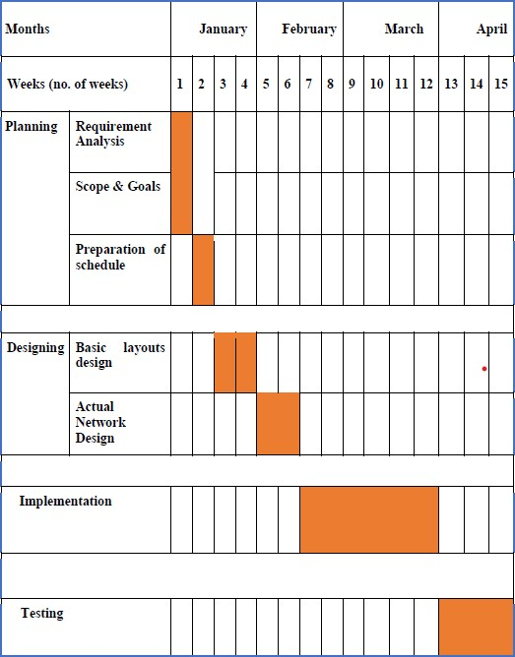

Chapter3 Design

3.Design

1. 1.ConstructionandDesign

3.1.1.Navigation

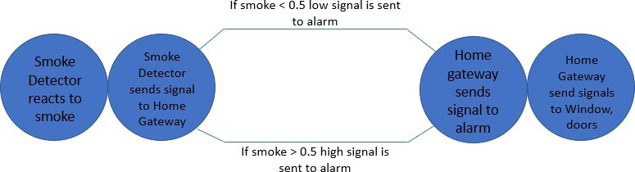

Figure3.1.SmokeDetector

3.1.2.Page

Layout

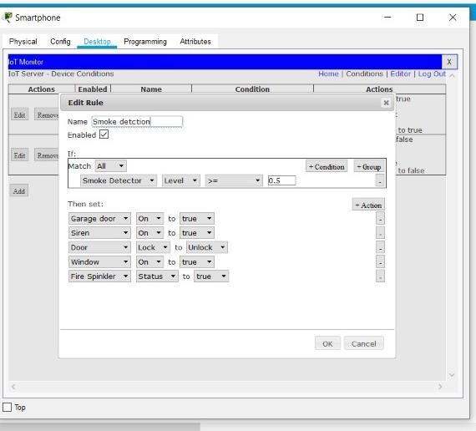

Figure3.2.SmokeDetectorOnRules

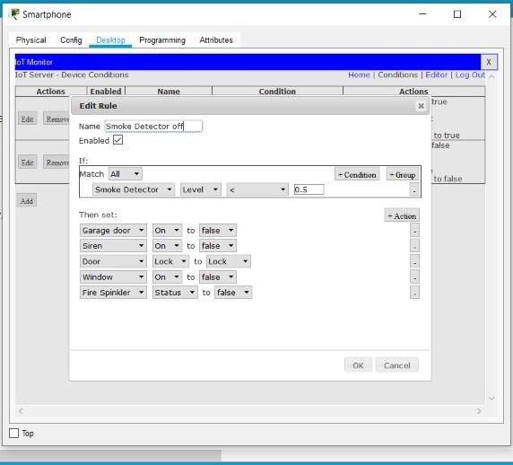

Figure3.3.SmokeDetectorOffrules

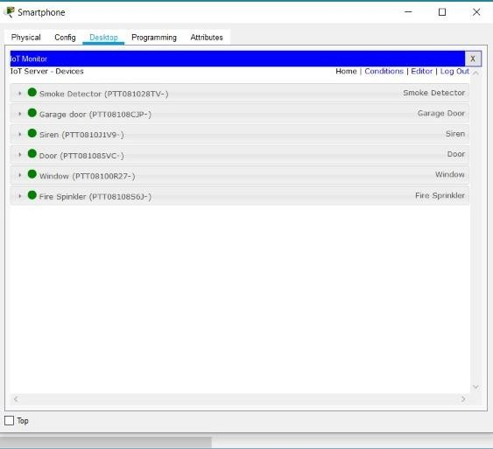

Figure3.4.Devicesinthesystem

## Chapter4 Implementation

4.Implementation

4.1.NetworkDesign

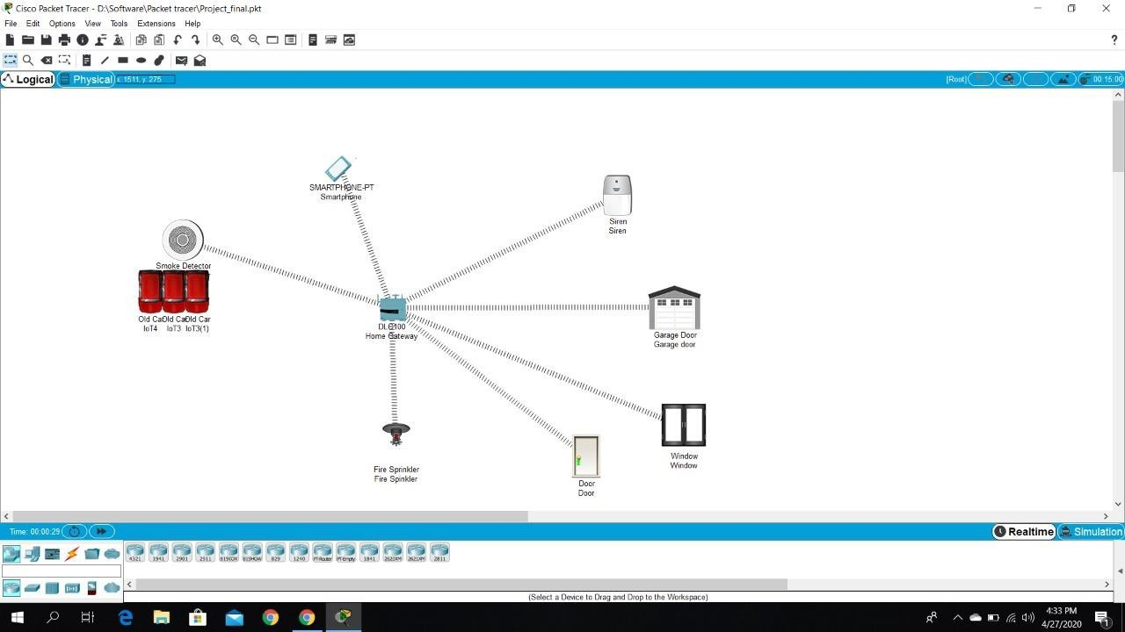

Fig4.1.NetworkDesign(Before)

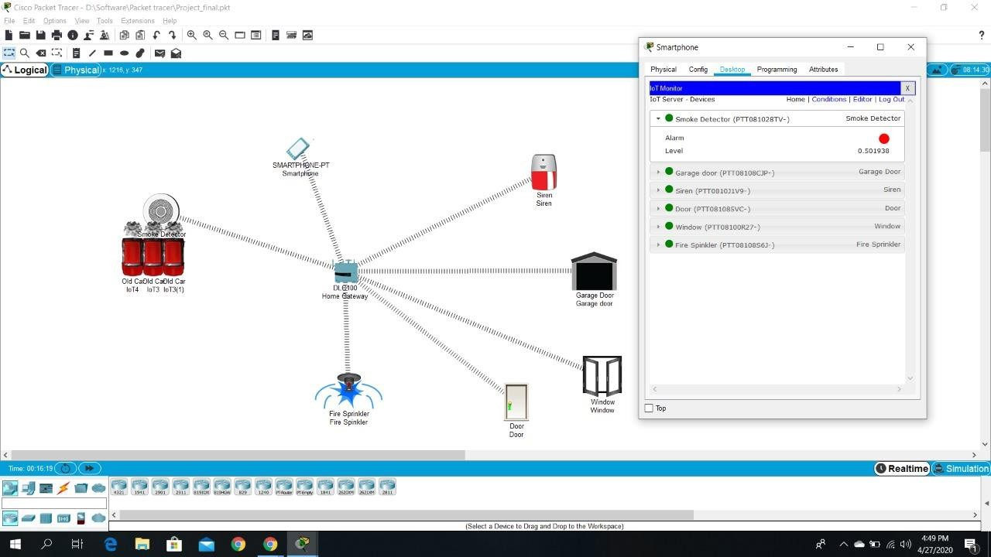

Fig4.2.NetworkDesign(After)

4.2.Configuration

1.DLCHomeGateway

•Createdawebpagewithusernameandpasswordtoconnectand gaincontrolofthesystem.

•Registrationcanbedoneonthisrouter.

•Rangeoftherouterissettomaximum(1000metersor1km).

•Ipaddressisassignedas192.168.25.1dynamically.

2.Smartphone

•Connecttothesystembygoingtothewebbrowserandentering theIPoftheregistrationserverandlogginginusingIDand Password.

•Ipaddressisassignedas192.168.25.100dynamically.

3.SmokeDetector

•SmokeDetectorisusedtodetectanysmoke.E.g.Whenafire breaksoutthesmokedetectorwilldetectit.Andinourproject whenthesmokelevelgoesbeyond0.5,certainconditionsare triggeredsuchasdoor,windowsareopenedandfiresprinklerand sirenareturnedon.

•ItisconnectedtoHomeGatewayusingadvancedsettinginI/O configi.e.(PT-IOT-NM-1W)networkadaptersetting.

•DynamicIPaddressisassignedusingDHCP.

4.Window

•Awindowisanopeninginawallthatallowsthepassageoflight, sound,andsometimesair.

•ItisconnectedtoHomeGatewayusingadvancedsettinginI/O configi.e(PT-IOT-NM-1W)networkadaptersetting •DynamicIPaddressisassignedusingDHCP

5.Door

•Adoorisanopeningfromwherepeoplecanenterorleaveina normalroutinelifeaswellasinemergency.

•ItisconnectedtoHomeGatewayusingadvancedsettinginI/O configi.e(PT-IOT-NM-1W)networkadaptersetting •DynamicIPaddressisassignedusingDHCP

6.Garagedoor

•AGaragedoorisanopeningfromwherevehiclescanenteror leave.Inourcasethisisverycrucialasgaragedoorsarehugeand canhelptheairescapewhenthereisafireoutbreak,releasing

carbondioxideandothergasesintotheairandhelpinganypeopleto takecleanairiftheyarestuckinthehouse.

•ItisconnectedtoHomeGatewayusingadvancedsettinginI/O configi.e.(PT-IOT-NM-1W)networkadaptersetting •DynamicIPaddressisassignedusingDHCP

7.Firesprinkler

•Thefiresprinklerspraysstreamsofwatertosuppressor extinguishthefirewhenorderedbythehomegateway.This happenswhensmokedetectordetectssmokelevelmorethan0.5.

•ItisconnectedtoHomeGatewayusingadvancedsettinginI/O configi.e(PT-IOT-NM-1W)networkadaptersetting •DynamicIPaddressisassignedusingDHCP

8.Siren

•Asirenisdevicewhichmakesaloudemergencysoundwhenthe smokedetectordetectssmokelevelgreaterthan0.5.

•ItisconnectedtoHomeGatewayusingadvancedsettinginI/O configi.e(PT-IOT-NM-1W)networkadaptersetting •DynamicIPaddressisassignedusingDHCP

9.Car

•InCisco-packettracerthereisnoobjectorentitywhichcan simulatethegenerationofsmokeotherthanacar.

•So,wehaveused3carstorepresentsmokegenerationwhichis similartosmokegeneratedduringfire.

Conditions:

Toimplementtheproject,weneedtospecifycertainconditionson whichallthedevicescanbeactivatedanddeactivated.Basedonhow andwhentheseconditionschange,therewillbechangesinthestateof thedevices.Tosimulatesmoke,wehaveused3cars.Theconditions whicharementionedaboveandarecrucialforthissimulationareas follows:

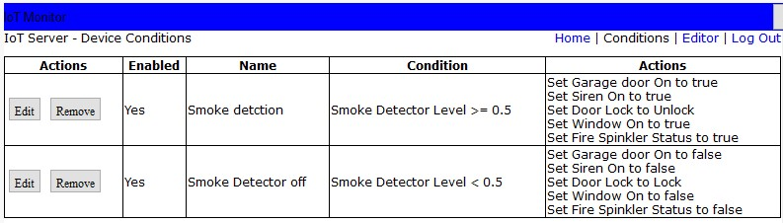

Fig4.3.SystemConditionsbasedonSituation

## Chapter5 TestingandDeployment

5.TestingandDeployment

Testin

g Table5.1.TestCases

| Test Case no. | TestCase | ExpectedOutput | ActualOutput | Result |
| --- | --- | --- | --- | --- |
| 1 | When  smokedetector detects smokelevel>  0.5 | Dooropen,  windowopen,garage dooropen, sprinkleron,sirenon. | Dooropen,  windowopen,garage dooropen, sprinkleron,sirenon. | Pass |
| 2 | When  smokedetector detects smokelevel<  0.5 | Doorclose,  windowclose,garage doorclose, sprinkleroff,sirenoff. | Doorclose,  windowclose,garage doorclose, sprinkleroff,sirenoff. | Pass |

Deployment

Thissystemcanbeofgreatindomesticaswellasindustrialsettingsto detectsmokeandalertpeopleonanimpendingfiresincesmokeisa precursorforfire,insteadofrelyingonheat/temperaturesensorswhich soundsalarmwhenthefirehasalreadystarted.Thiscangoalongwayin helpingtosavehumanlife.

## Chapter6 Maintenance

Maintenance:

Usermanual

1.Allthecomponentsmustberegularlycheckedforproperworking.

2.Basedontheconditionset,checkwhetheralldevicesareworking.

3.TheHomegatewayisupallthetime.

4.SmokeDetectorshouldbeabletodetectpresenceofsmokeallthetime.